Rectifiers Revisited 1 Improvements

Half wave rectifier 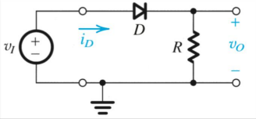***S***

Half wave rectifier ***S***

Assuming ideal diode

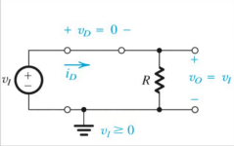

Half wave rectifier

***S***

Assuming ideal diode

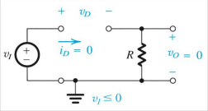

Half wave rectifier 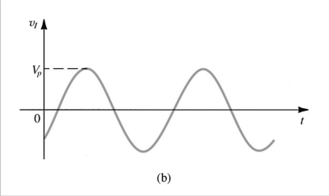

!" ***S***

Assuming ideal diode



Half wave rectifier

!"

***S*** Assuming ideal diode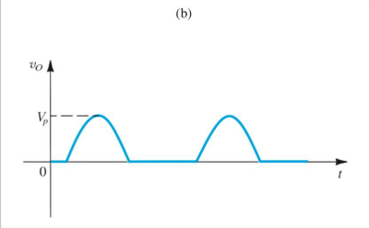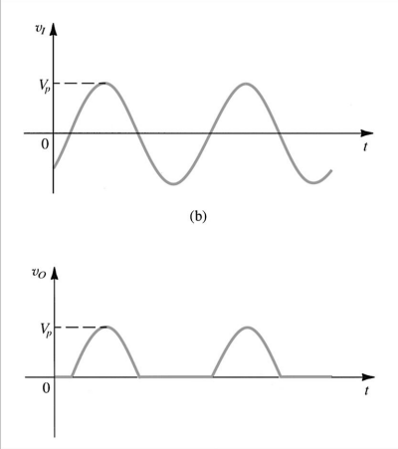

!" = !$

Half wave rectifier

***S***

Assuming ideal diode



***Transfer Characteristics***

Half wave rectifier

***S***

******Real diode

Half wave rectifier

***S***



******Real diode

Half wave rectifier

!"!" − !$

***S***

******Real diode

Half wave rectifier

!"!" − !$%& =!" − ($

***S***

)

Real diode

Half wave rectifier

!"!" − !$ %$ =!" − !$ 

'

***S***

So diode on when %$ > 0 hence when !" > !$

Real diode

Half wave rectifier

!"!" − !$ %$ =!" − !$ 

'

***S***

So diode on when %$ > 0 hence when !" > !$

When on, !*= !" − !$

Real diode

Half wave rectifier

!"!" − !$ %$ =!" − !$ 

'

***S***

So diode on when %$ > 0 hence when !" > !$

When on, !*= !" − !$

+ = , − !$

Half wave rectifier !"!" − !$ 

***S***

+,

+-

!" = +, sin 12

!*= +, sin 12 − +$

%$ =!" − !$

'

So diode on when %$ > 0 hence when !" > !$ When on, !*= !" − !$

!"

Half wave rectifier !"!" − !$ 

***S***

+,

+-

!" = +, sin 12

!*= +, sin 12 − +$

%$ =!" − !$

'

So diode on when %$ > 0 hence when !" > !$ When on, !*= !" − !$

!" 

+3 = 4567 89 8:24:2

= +, − +$

First improvement: Full wave rectifier

First improvement: Full wave rectifier Positive half cycle



First improvement: Full wave rectifier Positive half cycle



First improvement: Full wave rectifier Negative half cycle



First improvement: Full wave rectifier Negative half cycle



First improvement: Full wave rectifier Combining



First improvement: Full wave rectifier Positive half cycle



First improvement: Full wave rectifier Positive half cycle

!" = !$ − 2'(

First improvement: Full wave rectifier Negative half cycle



First improvement: Full wave rectifier Negative half cycle

!" = −!% − 2'(

First improvement: Full wave rectifier

!"

!&

$% 

!& = !" − 2!)

−$%

Second improvement: Capacitor smoothing

!" = !$ − !&



Second improvement: Capacitor smoothing

Second improvement: Capacitor smoothing